Proposal for Chess training at the Deens Academy

Chess “Smart people get smarter”

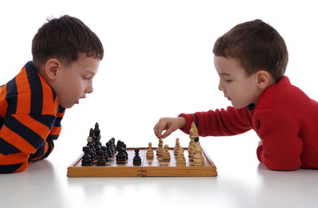
Promotes Imagination,creativity,
Develops Memeory,
Improves Concentration,
Develops Logical thinking,
Enhances analytical ability.
Chess Gurukul is first of its kind in India headed by the Indian Olympic Chess team coach Grandmaster R.B.Ramesh and his wife Women Grand Master Aarthie Ramaswamy.

Course Structure :
Every class will be structured to begin with explanation of concepts , practical examples, analysis of positions and idea followed by playing practice.
Group activities of problem solving and creating new ideas will be encouraged.

Contact : aarthie28@gmail.com / 09444409043

